Differential-Drive-RC-Boat
Project Overview
This project demonstrates the design and development of a Differential Drive RC Boat controlled using a FlySky FS-i6X radio transmitter and receiver system. The boat utilizes two DC motors driven by a dual-channel 4A Electronic Speed Controller (ESC), enabling wireless navigation and differential steering.
The system provides forward, reverse, left, and right movement by independently controlling the speed and direction of each motor. The project serves as a practical application of wireless control systems, motor control, and embedded electronics in marine robotics.
Features
- Wireless remote control using FlySky FS-i6X
- Differential drive steering mechanism
- Dual DC motor propulsion system
- Forward and reverse movement
- Independent motor control
- Compact and lightweight design
- Suitable for ponds and calm water environments

Hardware Components
Component | Quantity
FlySky FS-i6X Transmitter | 1
FlySky Receiver | 1
4A Dual Channel ESC | 1
DC Motors | 2
Propellers | 2
7.4V Li-Po Battery | 1
Boat Hull | 1
Connecting Wires | As Required

Circuit Diagram
The circuit consists of:
- FlySky FS-i6X transmitter and receiver pair
- Dual-channel 4A ESC
- Two DC motors
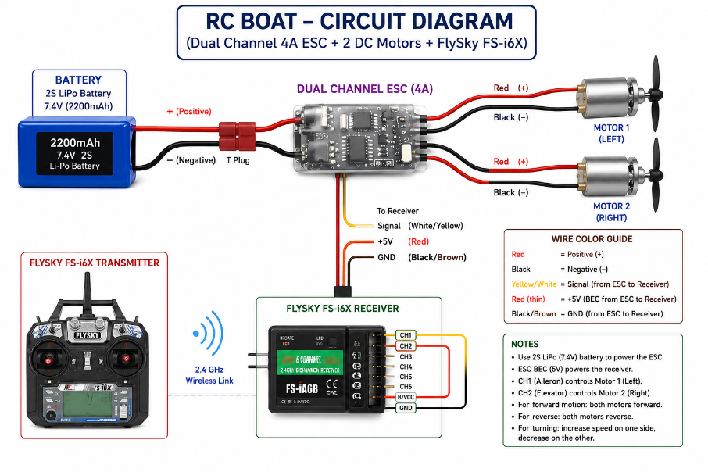
- 7.4V Li-Po battery
The receiver receives commands from the transmitter and sends control signals to the ESC. The ESC regulates power delivery to the motors, enabling speed and directional control.
Working Principle
- The FlySky FS-i6X transmitter sends wireless control signals.
- The receiver mounted inside the boat receives these signals.
- The dual-channel ESC interprets the commands and controls both DC motors.
- When both motors rotate at equal speed, the boat moves straight.
- By varying the speed of the motors independently, the boat turns left or right.
- Reversing both motors enables backward movement.
Differential Steering
Forward Motion
- Left Motor → Forward
- Right Motor → Forward
Reverse Motion
- Left Motor → Reverse
- Right Motor → Reverse
Left Turn
- Left Motor → Slower
- Right Motor → Faster
Right Turn
- Left Motor → Faster
- Right Motor → Slower
Applications
- Educational robotics projects
- Marine robotics demonstrations
- Remote-controlled water vehicles
- Wireless motor control studies
- Hobby and recreational applications
Project Outcome
The boat successfully demonstrated:
- Stable wireless communication
- Smooth forward and reverse operation
- Effective differential steering
- Reliable motor control using a dual-channel ESC
Future Improvements
- GPS-based navigation
- Autonomous waypoint tracking
- FPV camera integration
- Obstacle detection system
- ESP32-based telemetry
- LoRa communication
- ROS2 integration for autonomous control

